

CS241: Software Design & Implementation
School of Information Technology, Engineering, Mathematics and Physics

Final Examination Semester 2 2023

F2F Mode

Duration of Exam: 3 hours + 10 minutes
Reading Time: 10 minutes Writing Time: 3 hours

Total marks: 100

Instructions:
- This exam three sections.
- Section A 30 marks, Section B 40 marks, Section C 30 marks.
- This exam is worth 40 % of your overall mark.
- The minimum pass mark for this exam is 40 out of 100 marks.
- There are 15 pages in this paper including this cover page.
- This is a closed book Exam.
- Answer the questions in the spaces provided in the booklet.
- All the questions are compulsory. There are no choices.

Student Name:

Student ID:

~ALL THE BEST~

Section A: Short Answers (30 Marks)

Question 1 (10 marks)
- The waterfall model is a classical model used in system development life cycle to create a system with a linear and sequential approach. Discuss at least two advantages and one disadvantage of such model.
Advantages
- Before the next phase of development, each phase must be completed
- Suited for smaller projects where requirements are well define
- Project is completely dependent on project team with minimum client intervention
Disadvantages
- Error can be fixed only during the phase
- It is not desirable for complex project where requirement changes frequently
- Clients valuable feedback cannot be included with ongoing development phase
- A common feature of agile processes is stand-up meetings. What is stand-up meetings and its aim? Stand-up meetings are a key feature of agile processes, particularly in Scrum and Kanban, where team members gather daily to provide quick updates. Each participant shares what they’ve accomplished, what they plan to work on, and any obstacles they face. The primary aim of these meetings is to ensure team coordination, maintain focus, and foster communication. By identifying roadblocks early, the team can work together to resolve issues efficiently. Stand-up meetings promote accountability, transparency, and alignment with project goals, all while keeping discussions short and focused. Typically, these meetings are time-boxed to about 15 minutes to ensure productivity.
- You are a software developer working for a tech company that is developing a new social media platform. Your team is tasked with implementing a feature that automatically suggests friends to users based on their online interactions and interests. This feature uses advanced machine learning algorithms to analyze user behavior, comments, and content to make friend suggestions more personalized. Outline at least 1 ethical and 1 social issues that you as a developer need to take into account when developing this app. (3 marks)
As a software developer working on a social media platform that suggests friends based on user behavior, I must consider both ethical and social issues during development:
- Ethical Issue – Privacy Concerns: The app analyzes users' online interactions, comments, and content, which may raise privacy concerns. Users may not be fully aware of the extent to which their data is being collected and used for personalized suggestions. As a developer, it's crucial to ensure that data collection adheres to privacy laws (such as GDPR) and that users are informed about what data is being used and how. Consent mechanisms should be clear and easily accessible.
- Social Issue – Algorithmic Bias: The machine learning algorithms may unintentionally reinforce existing biases or create echo chambers. For example, the system might suggest friends who share similar views or interests, leading to the exclusion of diverse perspectives and potentially isolating users from different social groups. Developers must ensure that the algorithms are designed to promote diversity, fairness, and avoid reinforcing harmful stereotypes.
- Give any two strengths of Democratic Team Approach. (2 marks)
Egoless programming, Restructure the social environment, Restructure programmers’ values
Difficulty: Management may have difficulties, Democratic teams are hard to introduce into an undemocratic environment
Strengths: Democratic teams are enormously productive, They work best when the problem is difficult, They function well in a research environment

Question 2 (20 marks)
- Given below is a simple class diagram of a Home Heating system. Explain the relationships between each class as illustrated in the diagram. (3 marks)
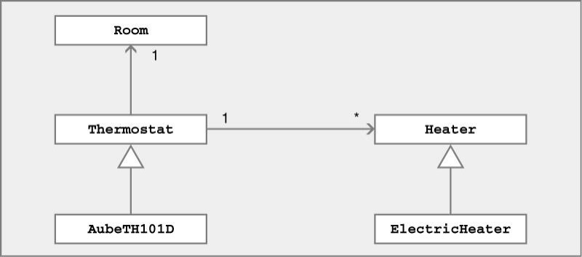

- What is an Entity, boundary and Control Class? (3 marks)

Entity Class: Represents data or business objects.
Boundary Class: Interfaces between the system and external actors (users or systems).
Control Class: Handles logic and coordinates the interactions between entities and boundaries.

- What is the purpose of the Model in Model-View-Controller (MVC) design pattern and give one advantage of using MVC pattern? (2 marks)
The Model in the MVC design pattern represents the data and business logic of the application. It is responsible for directly managing the data, responding to requests for information, and updating the data based on user input. The Model does not concern itself with the presentation or user interface (UI), which is handled by the View. It communicates with the Controller to update the View and reflect any changes to the data.

Advantage of Using MVC Pattern:
One key advantage of using the MVC pattern is separation of concerns. By dividing the application into three distinct components (Model, View, and Controller), it becomes easier to maintain and scale the application. Each component can be developed and modified independently, making it simpler to update the user interface (View) without affecting the underlying logic (Model) or to change business rules (Model) without disrupting the user experience (View). This modular approach also facilitates easier testing and debugging.

- Differentiate between Rational and Object-oriented database and give a drawback of an object oriented database (3 marks)
Relational databases (RDBMS) and Object-Oriented databases (OODB) differ in how they model and store data. RDBMS use tables to represent data, where rows are records and columns are attributes. Relationships between tables are established using primary and foreign keys, and data is queried with SQL. In contrast, OODBs store data as objects, similar to those used in object-oriented programming, which can contain both data and methods. They support complex structures like inheritance, encapsulation, and polymorphism. While relational databases have a rigid schema and data integrity enforced through constraints, OODBs offer a more flexible schema with direct object references, allowing complex relationships. However, a major drawback of OODBs is the complexity in querying and integration with other systems. Unlike SQL, which is widely known, OODB query languages such as OQL are more specialized and less commonly used, making it challenging to integrate with systems that rely on relational databases, limiting its adoption in diverse environments.

- In software engineering, what is a design pattern? Explain Singletons Pattern form of design patterns. (3 marks)
In software engineering, a design pattern is a reusable solution to a common problem that arises during software development. It provides a proven approach to solving specific design issues in a way that can be reused across different projects. Design patterns help developers avoid reinventing the wheel and enable more efficient, maintainable, and scalable solutions. These patterns are categorized into three main types: creational, structural, and behavioral.
One common creational design pattern is the Singleton Pattern. The Singleton Pattern ensures that a class has only one instance and provides a global point of access to that instance. This pattern is useful when only one instance of a class is needed to coordinate actions across the system, such as in cases of logging, database connections, or configuration settings.

- Configuration management (CM) is concerned with the policies, processes and tools for managing changing software systems. Differentiate between version management and release management and mention which tool is ideal for version management (3 marks)
Version Management deals with tracking and managing changes to the source code and artifacts.
Release Management ensures that the correct software version is deployed and delivered to users.
Ideal Tool for Version Management: Git is widely considered the ideal tool for version management due to its decentralized nature, robust branching and merging capabilities, and its integration with many platforms like GitHub and GitLab.

- Once the software is developed, there are different implementation strategies to deploy the system. One of the strategy is Direct Changeover and Parallel Running. Explain both the strategy and for a small-scale system which technique is more appropriate and why. (3 marks).
- Direct Changeover: In this strategy, the old system is completely replaced by the new system at once. The switch is made in a single, immediate changeover, where the new system becomes operational, and the old system is discontinued. This method is faster and more cost-effective, but it comes with a higher risk, as there is no fallback if the new system fails after the switch.
  - Advantages: Faster transition, reduced long-term costs.
  - Disadvantages: High risk, especially if the new system fails or encounters issues.
- Parallel Running: This approach involves running the old and new systems concurrently for a certain period. During this phase, both systems operate side-by-side, allowing users to get accustomed to the new system while still relying on the old one for backup. Only once the new system is proven to be stable, the old system is phased out.
  - Advantages: Lower risk, as the old system is still available as a backup.
  - Disadvantages: More expensive and time-consuming, as both systems must be maintained simultaneously.
For a small-scale system, Parallel Running is generally more appropriate. While it may require more resources upfront, the risks are significantly lower compared to Direct Changeover. A small-scale system is less likely to have the extensive resources or the ability to absorb failures without major disruptions. Parallel running allows time for thorough testing and ensures that users can transition to the new system smoothly without the fear of immediate failure. Thus, it provides a safer approach when the stakes are relatively lower and the system is smaller in scope.

Section B: Implementation and Testing (40 Marks)

Question 3 (5 marks)
- What is polymorphism in relation to oritented programming? (2 marks)
Polymorphism in object-oriented programming (OOP) refers to the ability of different objects to respond to the same method or message in different ways. This concept allows a single interface or method to be used for different underlying forms (types). In simpler terms, polymorphism allows objects of different classes to be treated as objects of a common superclass, with each subclass implementing the method in a way that is specific to its own behavior.
Polymorphism is one of the core concepts of object-oriented programming (OOP) that describes situations in which something occurs in several different forms.

- Using the following code snippet to answer the following questions.
class Animal {
public void animalSound() { System.out.println("The animal makes a sound");
}
}
class Pig extends Animal { public void animalSound() {
System.out.println("The pig says: wee wee");
}
}
class Dog extends Animal { public void animalSound() {
System.out.println("The dog says: bow wow");
}
}
class Main {
public static void main(String[] args) { Animal myAnimal = new Animal();
Pig myPig = new Pig(); Dog myDog = new Dog();
myAnimal.animalSound(); myPig.animalSound(); myDog.animalSound();
}
}

What is the output of the following code fragment?. (3 marks)
The animal makes a sound
The pig says: wee wee
The dog says: bow wow

Question 4 (20 marks)
Use the following UML class diagram to answer the given questions a - f:
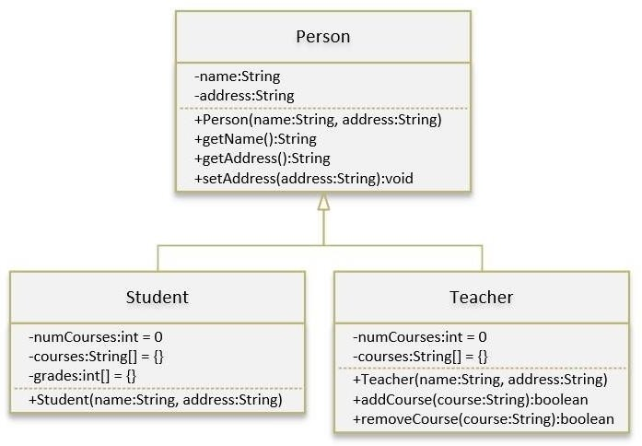
- State the base and derived classes. (2 marks)
Base Class: Person
Derived Classes: Student, Teacher

- List the Generic and Unique methods from the above classes. (2 marks)
Generic Methods (in Person class):
- Person(String name, String address)
- getName()
- getAddress()
- setAddress(String address)
Unique Methods:
- Student Class:
  - addCourseGrade(String course, int grade)
  - printGrades()
  - getAverageGrade()
- Teacher Class:
  - addCourse(String course)
  - removeCourse(String course)

- Write the implementation of Person class in Java to store properties and write any/all member functions implementation. (4 marks)
public class Person {
private String name;
private String address;

public Person(String name, String address) {
this.name = name;
this.address = address;
}

public String getName() {
return name;
}

public String getAddress() {
return address;
}

public void setAddress(String address) {
this.address = address;
}
}
- Write the implementation of Student class in Java to store properties and write any/all member functions implementation. For students, we need to maintain the courses taken and their respective grades. Assume that a student takes no more than 30 courses for the entire program. (4 marks)
public class Student extends Person {
private int numCourses = 0;
private String[] courses = new String[30];
private int[] grades = new int[30];

public Student(String name, String address) {
super(name, address);
}

public void addCourseGrade(String course, int grade) {
if (numCourses < 30) {
courses[numCourses] = course;
grades[numCourses] = grade;
numCourses++;
}
}

public void printGrades() {
for (int i = 0; i < numCourses; i++) {
System.out.println(courses[i] + ": " + grades[i]);
}
}

public double getAverageGrade() {
int sum = 0;
for (int i = 0; i < numCourses; i++) {
sum += grades[i];
}
return (double) sum / numCourses;
}
}

- Write the implementation of Teacher class in Java to store properties and write Teacher and addCourse member functions implementation. For teachers, we need to maintain the courses taught currently, and able to add or remove a course taught. Assume that a teacher teaches not more than 5 courses concurrently. (4 marks)

public class Teacher extends Person {
private int numCourses = 0;
private String[] courses = new String[5];

public Teacher(String name, String address) {
super(name, address);
}

public boolean addCourse(String course) {
if (numCourses < 5) {
courses[numCourses] = course;
numCourses++;
return true;
}
return false;
}

public boolean removeCourse(String course) {
for (int i = 0; i < numCourses; i++) {
if (courses[i].equals(course)) {
courses[i] = courses[numCourses - 1];
courses[numCourses - 1] = null;
numCourses--;
return true;
}
}
return false;
}
}
- Complete the main driver class to create objects of Student and Teacher classes. Call the relevant setter, getter functions and other member attributes/functions to enter following details (4 marks)
Student name: Jerry Fox, Address: Pacific Harbor Teacher name: Paul Walker, Address: Suva, Course: CS112

public class Main {
public static void main(String[] args) {
// Create Student object
Student student = new Student("Jerry Fox", "Pacific Harbor");
student.addCourseGrade("CS112", 85);

// Create Teacher object
Teacher teacher = new Teacher("Paul Walker", "Suva");
teacher.addCourse("CS112");

// Print details
System.out.println("Student Name: " + student.getName());
System.out.println("Student Address: " + student.getAddress());
student.printGrades();

System.out.println("Teacher Name: " + teacher.getName());
System.out.println("Teacher Address: " + teacher.getAddress());
}

Question 5 (10 marks)

Consider the following system with 13 modules and use it to answer questions a - e.
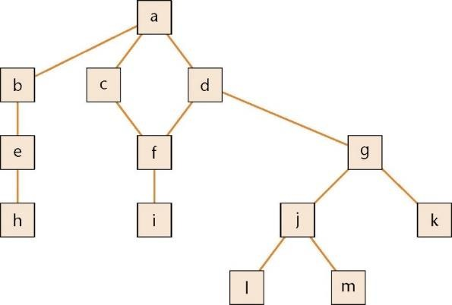

- What is a logical artefact? (1mark)
Logical artefact depicts the decision-making flow of control aspects of a product.

- What is an operational artefact? Give an example. (1mark)
Operational artefact performs the actual operations of the product.

- Observe the above interconnection diagram depicting the organisation of various modules in a software design. Identify the logical and operational artefacts from the diagram. (2 marks)
Logical artefacts: a, b, c, d, g j
Operational artefacts: e, f, h, i, k, l, m

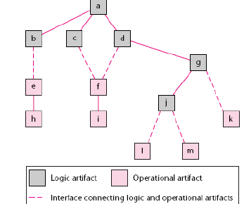
- Redraw the interconnection diagram to illustrate the sandwich integration in software implementation. (3 marks)

- Describe the sandwich integration strategy and give one advantage of this method. (3 mark)
Logic artifacts are integrated top-down. Operational artifacts are integrated bottom-up. Finally, the interfaces between the two groups are tested. // 2 marks
Adv // 1 mark
- Major design faults are caught early
- Operational artifacts are thoroughly tested
- They may be reused with confidence
- There is fault isolation at all times

Question 6 (5 marks)
- You are assigned in your current sprint to create a method that returns the grade of students based on the total marks they have received following the given rule:

A | B | C | D | E
80-100 | 65-79 | 50-64 | 49-30 | 29-0

*Assume the argument “Mark” is of type int and the method returns “X” for invalid marks

After implementing the method you are required to create unit test cases before your pull request can be processed.

Using Equivalence Partitioning, state all valid and invalid partitions. (3 marks)
Valid:
0<=mark<=29, 30<=mark<=49, 50<=mark<=64, 65<=mark<=79, and 80<=mark<=100 // 2 marks
Invalid:
Mark<0 and mark >100 // 1 marks

- the Pacific school children (<=18) get a discount 50% towards the bus fare. State the test inputs that would be selected using three-value BVA. (2 marks)

17, 18, 19

Section C: Case Study (30 Marks)

Question 7 (20 marks)
- The following is an event‐partitioned data flow diagram for buying a movie ticket at Damodar City,
Suva. Using the transaction analysis technique, develop a structure chart for it (6 marks).
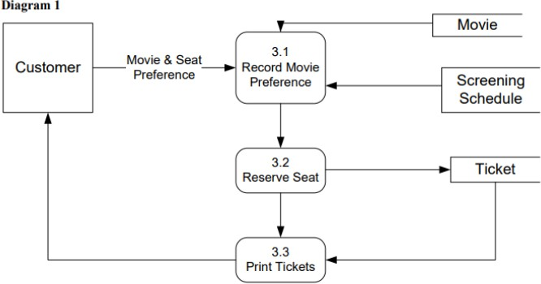

- Draw a UML Class Diagram representing the following elements from the problem domain for a Candy Vending Machine. (8 marks)

A Candy vending machine sells small, packaged, ready to eat items (chocolate bars, cookies, candies, etc.). Each item has a price and a name. A customer can buy an item, using a smart Vcard (issued by the vending machine company) to pay for it. No other payment forms (i.e. cash, credit card) are allowed. The Vsmart card records on it the amount of money available. The functions supported by the system are: Sell an item (choose from a list of items, pay item, distribute item), Recharge the machine, Set up the machine (define items sold and price of items), Monitor the machine (number of items sold, number of items sold per type, total revenue). The system can be used by a customer, a maintenance employee (who recharges items in the machines), an administrator (who sets up the machine).
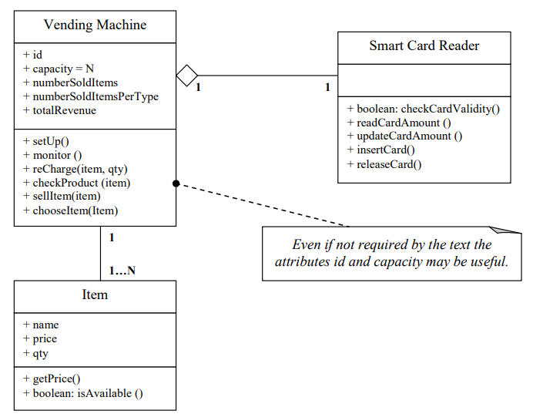

- Provided below is the basic flow obtained from a use case description. Draw a sequence diagram for the scenario. (6 marks)
- A Worker tells a System the identity of a patron who wishes to check out books.
- The System confirms that the patron is allowed to check out books, and remembers the patron's identity.
- The Worker tells the system the identity of a book this patron is checking out.
- The System confirms that the book can circulate, calculates the due date based on whether the patron is a faculty member or a student, and records that the patron has checked out this book, which is due on the calculated due date, and makes that information available from the library catalog.
- The System tells the Worker the due date (which also confirms that the book has been checked out). The Worker repeats steps 3-5 until indicates done

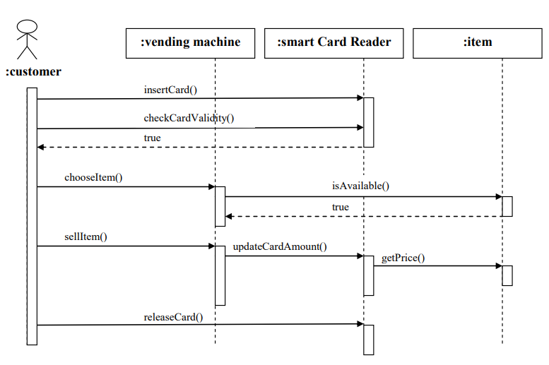

Question 8 (10 marks)
Case Study: Fashionable e-commerce

Read the problem statement given below very carefully and use it to answer the questions that follow.

World’s Trend is a mail order supplier of high-quality, fashionable clothing. Customers place orders by telephone, by mailing an order form included with each catalog, or via the Web site.
Summary of Business Activities
  - When customer orders come in, the item master and the customer master files are both updated. If an item is out of stock, the inventory control department is notified.
  - If the order is from a new customer, a new record is created in the customer master file.
  - Picking slips are produced for the customer order and sent to the warehouse.
  - A shipping statement is prepared.
  - The process of shipping a customer order involves getting the goods from the warehouse and matching up the customer shipping statement, getting the correct customer address, and shipping it all to the customer.
  - The customer statement is generated and a billing statement is sent to a customer once a month.
  - An accounts receivable report is sent to the accounting department.
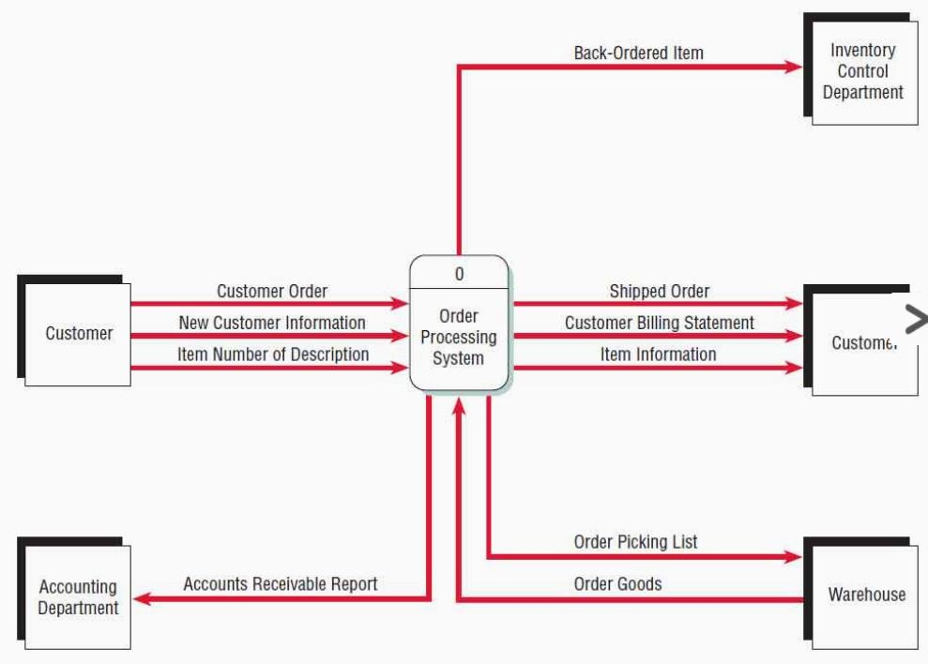

a) Use the Context-level DFD of Fashionable e-commerce to draw Level 1 DFD (10 marks).
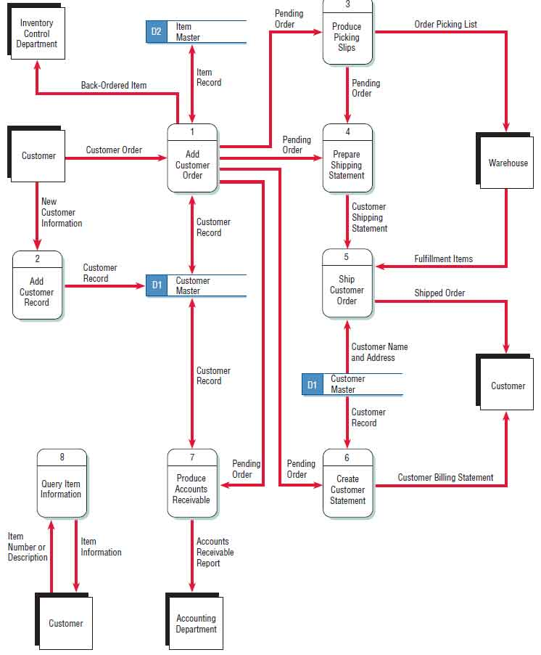
THE END

